

**EAST WEST UNIVERSITY**

Summer-2020

Project Report

**Project Name: Microprocessor-based automatic door opener.**

Course code: CSE360

Course title: Computer Architecture.

Section: 01



**Submitted To:**

Dr. Ahmed Wasif Reza

Associate Professor

Dept. of CSE.

**Submitted by:**

Snehashis Ghosh Pial (ID: 2017-2-60-163)

Date of Submission: 24/09/2020

1. **Title:** Microprocessor-based automatic door opener.

1. **Objective:**

Automatic doors have many useful purposes, which is why we can find them in many different types of locations. From supermarkets to airports and many types of large buildings, automatic doors make it easier for people to get into and out of buildings. They are especially helpful for people who are handicapped. The system specified in this project associates the use of a microprocessor as a controller. It uses a far off control convenience to keep away from the stress of manually opening and closing the gate. The technology used eliminates gate monitoring and maintaining by way of human beings.

1. **Theory:**

This project proposes a system of automatic opening and closing of door by found any body movement near the door. The Certain specifications, parameters, and strategies of implementation ought to be regarded in system design and construction in order to provide the anticipated result. The implementation of the diagram includes segmenting the overall system design into modules, which are individually designed and examined earlier than the integration of the various subsystems. The system design is divided into:

1. Hardware Design components needed:

i)Ultrasonic sensor

ii)Arduino

iii)Servo motor

iv)Trigger circuit

v) Breadboard

vi)Male to male connector

vii)Gate control unit

b)Software

i) Arduino 1.8.13

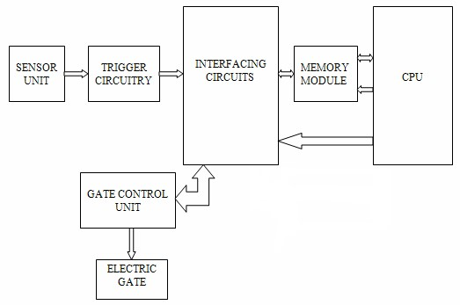**4. Design:**

Figure: Block Diagram of the system

The working of these components is as follows:

Sensor:

Ultrasonic sensors also known as transceivers when they both send and receive, but more generally called transducers work on a principle similar to radar or sonar which evaluate attributes of a target by interpreting the echoes from radio or sound waves respectively. Ultrasonic sensors generate high frequency sound waves and evaluate the echo which is received back by the sensor. Sensors calculate the time interval between sending the signal and receiving the echo to determine the distance to an object.

This technology can be used for measuring wind speed and direction(anemometer),tank or channel level and speed through air or water. For measuring speed or direction a device uses multiple detectors and calculates the speed from the relative distance to particulates in the air or water. To measure tank or channel level, the sensor measures the distance of the surface of the the fluid. Further application include: humidifiers, sonar,medicalultrasonography,burglar alarms and non-destructive testing. System typically use a transducer which generates sound waves in the ultrasonic range , above 18,000 hertz. Generally, Ultrasonic sensor can detect animal/human movement in a requirement range, which is determined by the spec of the specific sensor.

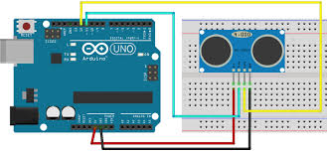

Figure: Block Diagram of Ultrasonic

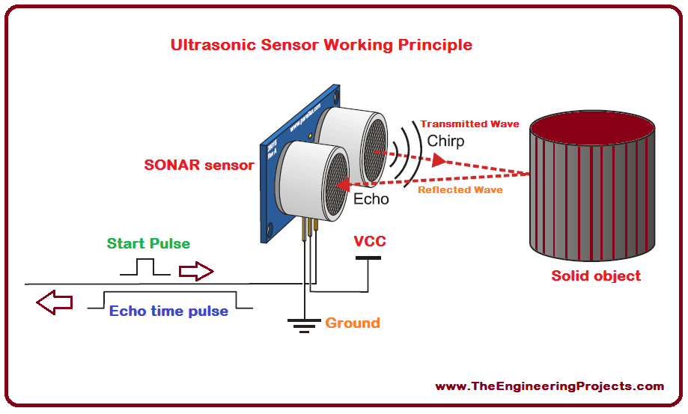

Figure: Ultrasonic sensor How it works

Trigger circuit:

The trigger circuitry serves as an Analog–to–Digital converter (ADC), which produces a HIGH signal when the beam is interrupted. It accepts the output of the two sensor units. Its function is to NOR the two inputs from the sensing unit, clip, and shape the pulse into square waves. It is configured in such a way that when there is an output from any of the two sensing units will the trigger circuitry go HIGH, else it remains at LOW level. The trigger circuitry sends a signal to the interface unit, which is made up of Programmable Input /Output Controller (PIO). The software causes the microprocessor to be check the input port of the interface unit for the sensor status information (the outputs of the trigger circuitry). A HIGH value causes the microprocessor to

send a signal to the output port of the interface unit in order to activate the DC motor to control the gate (open and close).

Algorithm:

The algorithm used to implement the program for the system described in this paper is as follows:

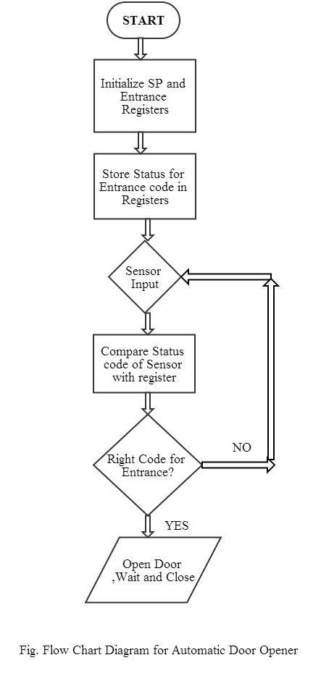

START

1. Initialize the Microprocessor
2. Fetch the status of the sensor bit
3. Compare the status of the sensor bit with entrance code
4. If status = entrance code then step 5
5. Else step 4
6. Go to step 2
7. Gate open, wait and close

**5. Implementation:**

Hardware requirement

i)Ultrasonic sensor

ii)Arduino

iii)Servo motor

iv)Trigger circuit

v) Breadboard

vi)Male to male connector

vii)Gate control unit

Software requirement

1. Arduino 1.8.13

ARDUINO UNO

The Arduino Uno is a micro-controller board based on the ATmega328 It has 14 digital input/output pins (of which 6 can be used as PWM outputs), 6 analog inputs, a 16 MHz ceramic resonator, a USB connection, a power jack, an ICSP header, and a reset button. It contains everything needed to support the micro controller; simply connect it to a computer with a USB cable or power it with a AC-to-DC adapter or battery to get started.

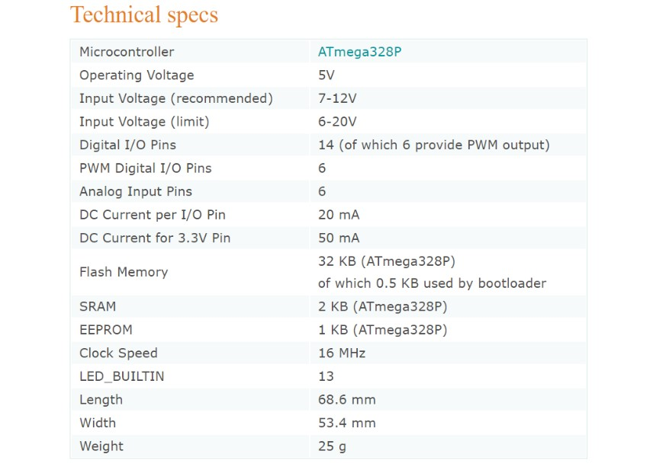

Connecting to Ultrasonic:

The hardware part of this project is very easy to put together. First of all, make the connections for the ultrasonic sensor with the Arduino. The connections for the ultrasonic sensor with the Arduino are as follows:

* Connect VCC on the ultrasonic sensor to the 5V pin on the Arduino.
* Connect the Trig pin on the ultrasonic sensor to pin 2 on the Arduino.
* Connect the Echo pin on the ultrasonic sensor to pin 3 on the Arduino.
* Connect the GND on the ultrasonic sensor to GND on the Arduino.

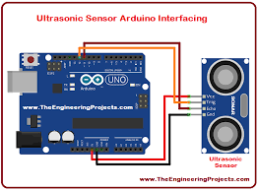

After that, make the connections for the buzzer and the Arduino. Connect the positive pin on the buzzer with pin 10 on the Arduino and the buzzer's negative pin with the GND pin on the Arduino.

Servo motor:

A servo motor has everything built in: a motor, a feedback circuit, and most important, a motor driver. It just needs one power line, one ground, and one control pin.

Following are the steps to connect a servo motor to the Arduino:

1. The servo motor has a female connector with three pins. The darkest or even black one is usually the ground. Connect this to the Arduino GND.
2. Connect the power cable that in all standards should be red to 5V on the Arduino.
3. Connect the remaining line on the servo connector to a digital pin on the Arduino.

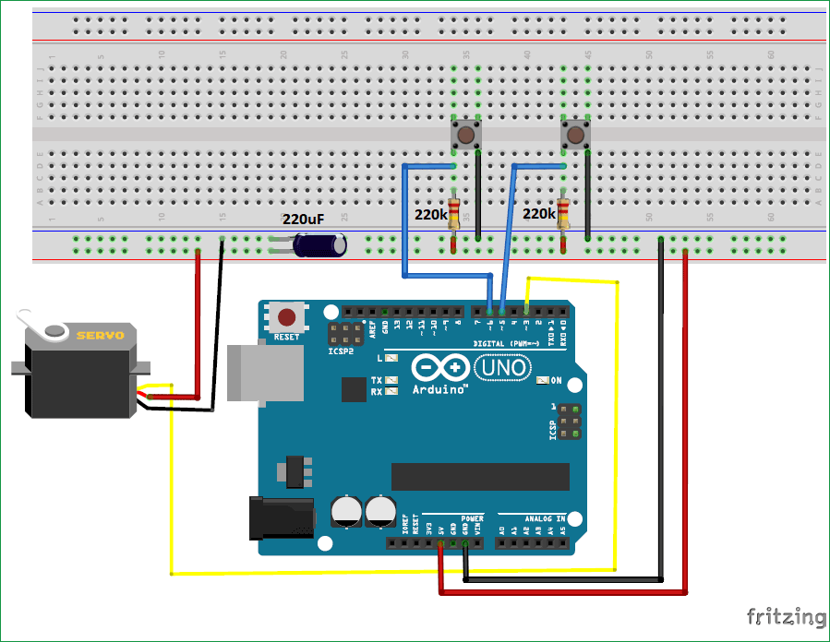

Figure: Servo motor interfacing with Arduino

Stall Condition:

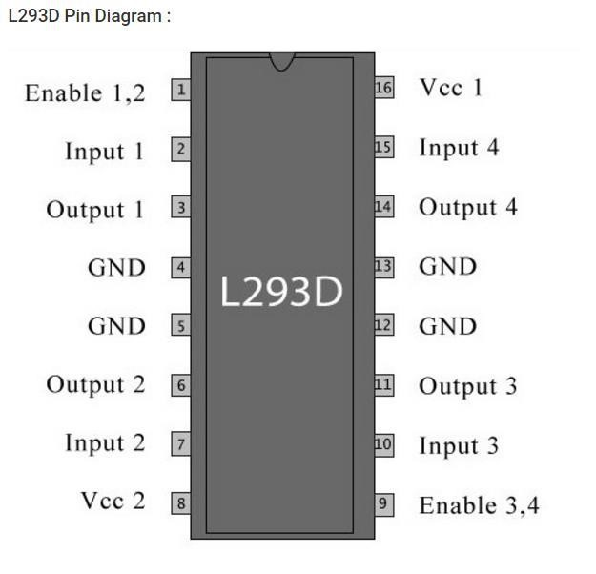When the motor is applied positive voltage on both sides then the voltage from both the sides bring the motor shaft to a halt.

Voltage Specification:

VCC is the voltage that it needs for its own internal operation 5v; L293D will not use this voltage for driving the motor. For driving the motors, it has a separate provision to provide motor supply VSS (V supply). L293d will use this to drive the motor. It means if you want to operate a motor at 9V then you need to provide a Supply of 9V across VSS Motor supply. The maximum voltage for VSS motor supply is 36V. It can supply a max current of 600mA per channel. Since it can drive motors Up to 36v hence you can drive pretty big motors with this l293d. VCC pin 16 is the voltage for its own internal Operation. The maximum voltage ranges from 5v and up to 36v.

Programming Code Explanation:

#include <Servo.h> //library for servo motor

Servo servo1; //create servo 1 object to control a servo

int trigPin = 9; //declare the pin which we use in our project for output

int echoPin = 8; //declare the pin which we use in our project for input

long distance;

long duration;

void setup()

{

servo1.attach(7); //servo 1 connect in 7 no pin

pinMode(trigPin, OUTPUT); //output pin number input function

pinMode(echoPin, INPUT); // input pin number input function

}

void loop()

{

ultra_sonic();

servo1.write(90); //the indicator was in 90 degree angle

if(distance <=9)

{

servo1.write(270); //if object distance less than or equal 9cm indicator shift

} //270 degree

}

void ultra_sonic()

{

digitalWrite(trigPin, LOW); //This function put the trigpin low pulse

delayMicroseconds(2); //low pulse stage remain for 2 ms

digitalWrite(trigPin, HIGH); //This function put the trigpin high pulse

delayMicroseconds(10); //high pulse stage remain for 10 ms

digitalWrite(trigPin, LOW); //This function put the trigpin low pulse

duration = pulseIn(echoPin, HIGH); //pulse in function detect pulse time and save it to duration

distanceCm = duration*0.034/2; //distance=speed*time

}

1. **Result Analysis**:

Test case 1:

When first object come near to the ultrasonic sensor distance less than or equal 9 the receiver or echo detect the reflective pulse , the gate opened, wait and closed.

Test Case 2:

When 2nd object go far from the sensor it can not detect the pulse transferred by transducers. So the door could not open.

1. **Conclusion and Future Improvements:**

The building of a microprocessor primarily based device had been performed in this project. This layout can be easily adapted to any electric powered gate and any shape of control which requires the use of sensors. Every good project has limitations; the drawback of this design lies in the effectiveness of the sensor. The sensor will work most successfully when the environment is noise free. In noisy environment it can not detect the pulse signal appropriately.

Advantages of automatic door opening system:

* + For people in wheelchairs and other disabled individuals, automatic doors are an immense boon, since conventional doors can be very hard to work with. It may be impossible to open a conventional door while seated in a wheelchair or navigating with crutches.
  + In hospitals and scientific labs, automatic doors can be used to secure an area by ensuring that the doors are shut at all times, while reducing the risk of cross-contamination since people do not need to handle the doors to pass through them.
  + Automatic doors can also be useful in warehouses and other facilities where people frequently have their hands full, contributing to safety and efficiency by making it easier for people to get around.

Future Improvements:

* + There can be a Display Unit for showing number of persons entered in a particular room.
  + There can be a password system which can block the unexpected person.
  + The sensor always open the door in emergency situation.
  + To achieve full automation, a real-time system should be employed and a Closed-Circuit Television (CCTV) system provided for proper monitoring and security purposes. This can be helpful in detecting the presence of vehicles before the system is activated.
  + Upgrading the system using higher bit microprocessors for speed optimization.
  + Along with this system we can use Face-detection through Camera for Automated Attendance System.

**ACKNOWLEDGMENT:**

We would like to thank our honorable course instructor Dr. Ahmed Wasif Reza sir for giving us the chance to work with this wonderful project.